

Firewall s WAN Security Assessment using pfSense

Student Name: AMMAR IQBAL
Roll Number: 03
Course: Cybersecurity

Institution: Software Technology Park – ROHI eSkills Learning Hub
Date: 02 January 2026

Introduction
Modern enterprise networks rely heavily on perimeter firewalls to protect internal systems from unauthorized access, reconnaissance, and exploitation attempts originating from the public internet. This assignment presents a comprehensive firewall and WAN security assessment of a pfSense-based network. The objective of the assessment is not to exploit the system, but to evaluate its exposure, observe firewall behavior, identify reachable services, and assess the overall security posture using controlled and ethical reconnaissance techniques.
This assessment was conducted strictly in accordance with lab rules and ethical guidelines. No active exploitation, credential attacks, or firewall bypass attempts were performed. All findings are based on observation, enumeration, and analysis of responses provided by the target system.

Objective
The primary objectives of this assessment were: - To understand the architecture and role of pfSense within the given network - To identify any externally reachable ports and services - To analyze how the firewall responds to different scanning techniques - To assess potential risks and vulnerabilities based on observed exposure - To document findings with evidence and provide security recommendations

Network Overview and Architecture
The target network is protected by a pfSense firewall deployed at the perimeter. The firewall connects the internal organizational networks to the public internet using dual WAN links with NAT and load balancing enabled.

Key Characteristics:
- Firewall Platform: pfSense
- Public WAN IP Address: 110.39.164.74
- WAN Configuration: Dual WAN with NAT and load balancing
- Firewall Policy: Default deny-all
- Internal Segments:
  - Student Network (LAN 1)
  - Employee Network (LAN 2)
  - Internal Servers Network
All inbound traffic from the internet terminates at the pfSense firewall. Only explicitly allowed services are reachable, while all other traffic is silently filtered or dropped.

Tools Used
The following tools were used during the assessment: - Kali Linux (VMware Workstation) – Penetration testing operating system - Nmap 7.G5 – Network scanning and service detection - Nikto 2.5.0 – Web server vulnerability scanning - DIRB 2.22 – Directory and file enumeration - curl – HTTP header and response inspection - nslookup – DNS resolution testing - WhatWeb – Web application fingerprinting - Web Browser – Manual verification of web interfaces

Methodology
The assessment followed a structured, phased approach to ensure accuracy, safety, and compliance with lab rules.

Phase 1: Host Discovery
Initial scans were conducted to confirm whether the target host was reachable and to observe how the firewall handles ICMP and probe traffic.
Commands used: - nmap 110.39.164.74 - nmap -Pn 110.39.164.74
The firewall largely suppressed ping responses, indicating ICMP filtering.
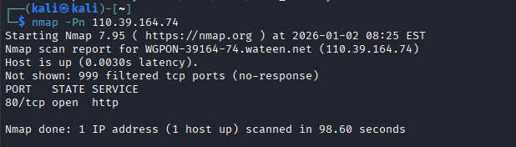

Phase 2: Firewall Behavior Analysis (ACK Scan)
ACK scans were used to identify firewall filtering behavior without attempting to open connections.
Command: - nmap -sA 110.39.164.74
Results indicated that ports were in filtered or ignored states, demonstrating stateful firewall enforcement.

Phase 3: TCP Port Scanning
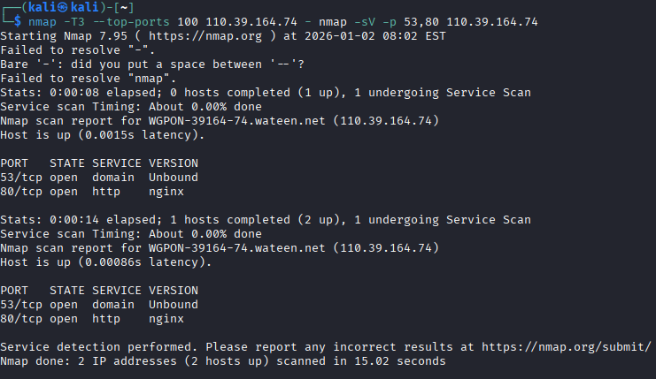
Top TCP ports were scanned using conservative timing options to identify reachable services.
Commands: - nmap -T3 --top-ports 100 110.39.164.74 - nmap -sV -p 53,80 110.39.164.74

Phase 4: UDP Scanning
Limited UDP scanning was performed due to the noisy nature of UDP scans.
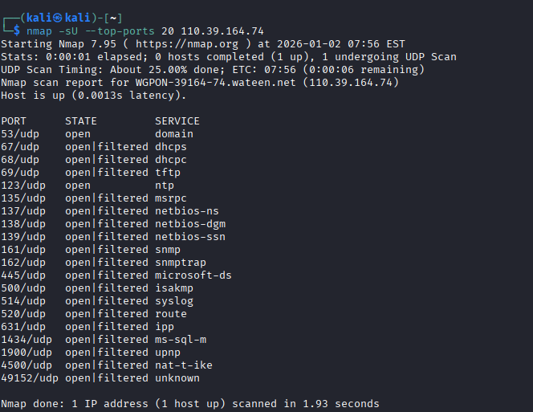
Command: - nmap -sU --top-ports 20 110.39.1No exploitable UDP services were discovered.

Phase 5: Service and Web Enumeration
Web-related enumeration was performed on the reachable HTTP service.

Commands: - curl -I http://110.39.164.74 - nmap -p 80 --script http-enum 110.39.164.74 -
dirb http://110.39.164.74/ - whatweb http://110.39.164.74
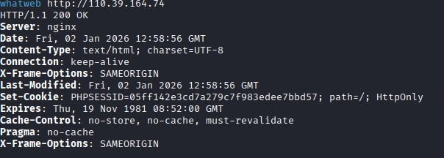
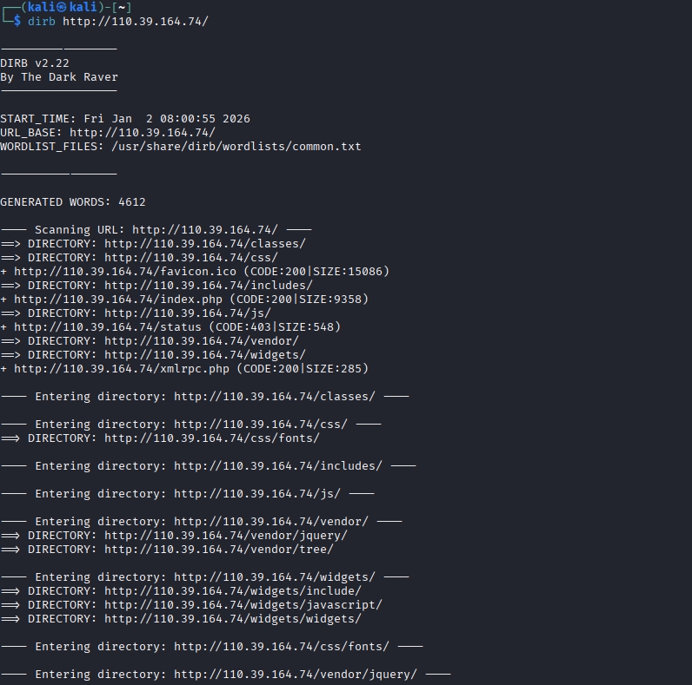
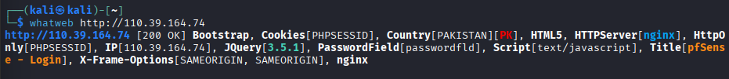
Manual verification was conducted using a browser.

Findings

Open and Reachable Ports

Port | Protocol | State | Service | Description
53 | TCP | Open | DNS (Unbound) | DNS service reachable; no recursion or zone transfer observed
80 | TCP | Open | HTTP (nginx) | pfSense web interface reachable
All other scanned ports were filtered or dropped.
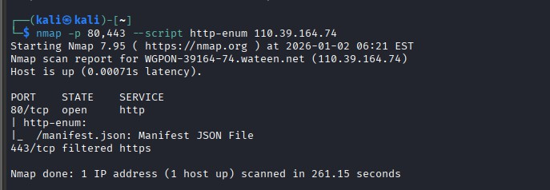

HTTP Service Analysis
    - Server identified as nginx
    - pfSense login page accessible over HTTP
    - Security headers observed:
      - X-Frame-Options: SAMEORIGIN
      - HttpOnly session cookies
    - HTTPS (443) appeared filtered or unavailable
    - CSRF protection mechanisms were observed during invalid requests

    - 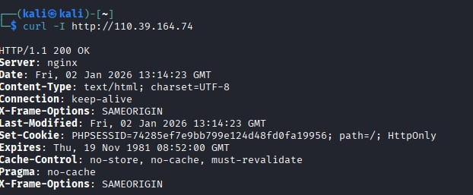

DNS Behavior
DNS queries sent directly to the firewall resulted in timeouts, indicating that the DNS service does not act as an open resolver.

Directory and Resource Enumeration
Directory enumeration revealed common application paths consistent with pfSense, including: -
/index.php - /status - /vendor/ - /includes/
No sensitive configuration files were accessible.
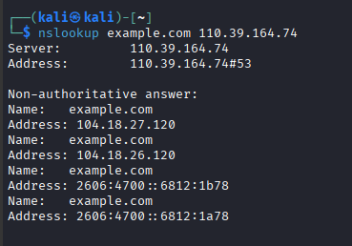

Firewall Behavior Analysis
The pfSense firewall demonstrated the following defensive behaviors: - Default Deny-All Policy: Only explicitly allowed services responded - Stateful Packet Inspection: ACK scans confirmed filtering without RST leakage - NAT Protection: Internal IP addresses were fully concealed - Segmentation: No evidence of access to internal networks - CSRF Protection: Invalid POST requests triggered CSRF errors

Vulnerability and Risk Assessment

Observed Exposure
    - HTTP service exposed on port 80
    - DNS service reachable but hardened
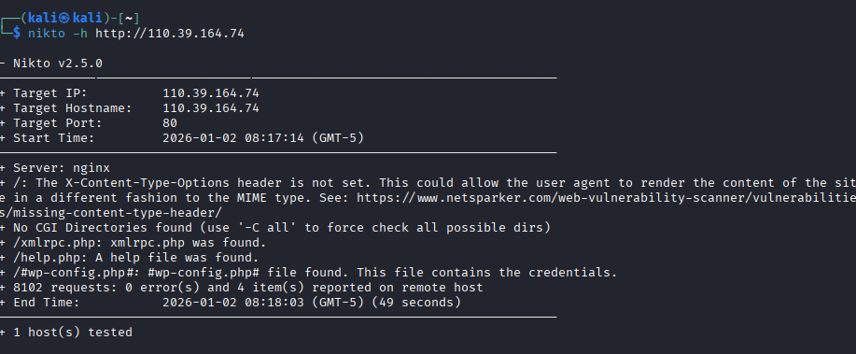
    - Product fingerprinting possible via UI and headers

Referenced CVEs (Contextual Only)

CVE ID | Affected Versions | Description
CVE-2024- 23492 | ≤ 2.7.2 | API command injection (requires exposed API)
CVE-2023- 38260 | 2.6.0–2.7.0 | Authentication bypass vulnerability
CVE-2022- 26376 | CE 2.6.0 | Language injection issue
CVE-2021- 32764 | ≤ 2.5.0 | Package editor command injection
CVE-2020- 20243 | HAProxy plugin | Configuration disclosure vulnerability
No CVE was directly exploitable based on observed exposure.

6. Overall Risk Evaluation

Threat | Likelihood | Impact | Risk Level
External scanning | Low | Low | Low
Web UI abuse | Low | Medium | Low
Denial of Service | Medium | Medium | Medium
Misconfiguration | Medium | High | High

Threat | Likelihood Impact | Risk Level
Insider threat | Medium High | High

- Security Recommendations
  - Enforce HTTPS-only access for pfSense management
  - Restrict administrative access to VPN-only connections
  - Enable IDS/IPS (Snort or Suricata)
  - Regularly update pfSense and installed packages
  - Disable unused services and plugins
  - Implement centralized logging and alerting

Screenshots and Evidence
All screenshots collected during the assessment are attached and labeled sequentially, demonstrating scan outputs, firewall responses, and service behavior.

Conclusion and Lessons Learned
The pfSense firewall demonstrates a strong security posture with minimal external exposure and effective filtering. The assessment confirmed that the firewall successfully prevents unauthorized access, suppresses reconnaissance attempts, and protects internal networks through NAT and segmentation. The most significant risks are misconfiguration and potential exposure of administrative interfaces in the future. Continuous monitoring, patching, and adherence to security best practices are essential to maintaining this posture.
This assignment reinforced the importance of defensive configuration, ethical assessment practices, and proper documentation in real-world cybersecurity operations.

